# Events and Event Emmiter

## 31. Events

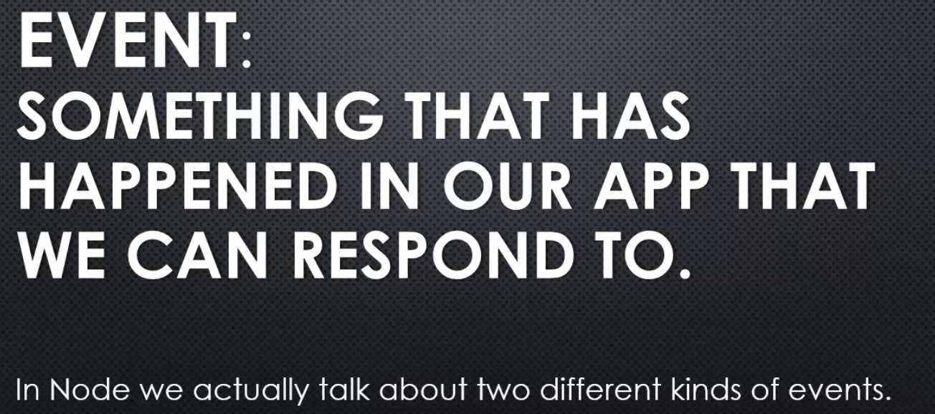

The concept of events and listening to or responding to events, is in many areas of software architecture and on many platforms.

 in Node, we actually talk about two different kinds of events.

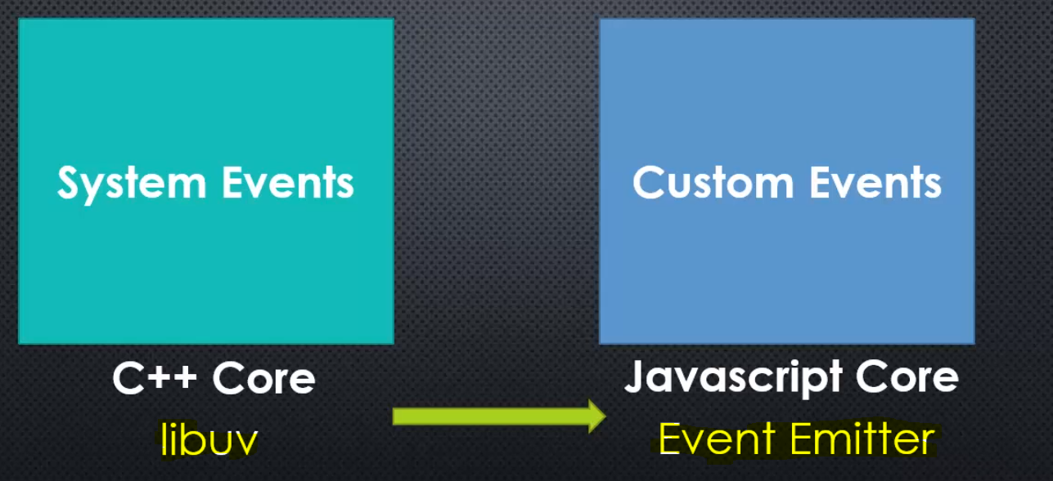

on one side, in Node.js, you're dealing with system events. And that comes from the C++ side of the Node.js core, thanks to a library called libuv,

But that's the C++ code, the library of C++ code that's part of Node.js that deals with events coming from the computer system, lower level, closer to the machine.

Like, I finished reading a file, the file is open, I've received data from the Internet,

and other things like that, things that JavaScript doesn't have.

**On the other side, we have custom events in Node.js, which are completely different.**

They're inside the JavaScript core. It's a JavaScript library of events that deals with events that I can create for myself. Where I can, in my code say, hey this happened and have code that responds to something happening. However, this is not part of the C++ libuv,

this is the event emitter inside the JavaScript core. It's a JavaScript file that contains the code for what's called the event emitter.

However, we often get confused because, remember the JavaScript code often wraps calls to the C++ side of Node. So oftentimes, when an event occurs in libuv, it generates a custom JavaScript event, to make it easier for us to manage our code and decide what code should run when that event happens.

**So, you can think of it sometimes as if it was just one thing, but it's not.**

As we're about to see, the JavaScript side is faking it, it's not real events.

What do we mean by that?

Well JavaScript doesn't have an eventing concept, there's no event object in JavaScript.

But we can fake it, we can create our own event library, our own way of creating, telling the code that something has happened and responding to that something happening

with the technique that the Node event emitter uses.

## 33. The Node Event Emmiter – Part 1

**Lets first try to create our own Event emitter**

I'll create a new file, I'll call it emitter.js.

And this is going to allow us to say an event has happened, and to respond to the event happening.

I could create this in a number of different ways.I'm going to choose to use a function constructor. I could use a class, an ES6 class for example, if I was running ES6, or I could create an object in other ways, but we'll just create the object by using a function constructor. so that I can create multiple emitters that I might want in my application.

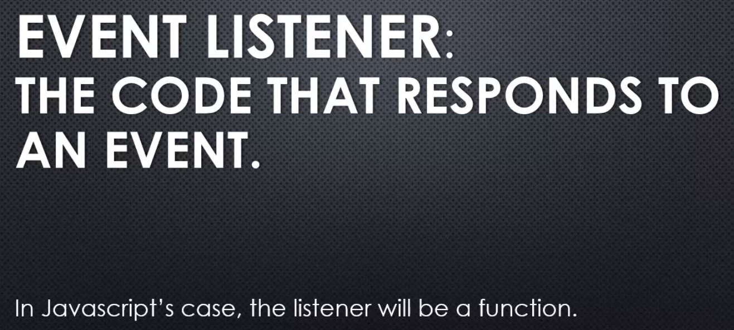

So when an event happens, this function will be invoked. And you can have many listeners listening for the same event.

So one event happens, and perhaps all over your application you have different listeners listening for that event. When the event happens, all the listeners

will be invoked. Not simultaneously, one at a time in javascript's case.

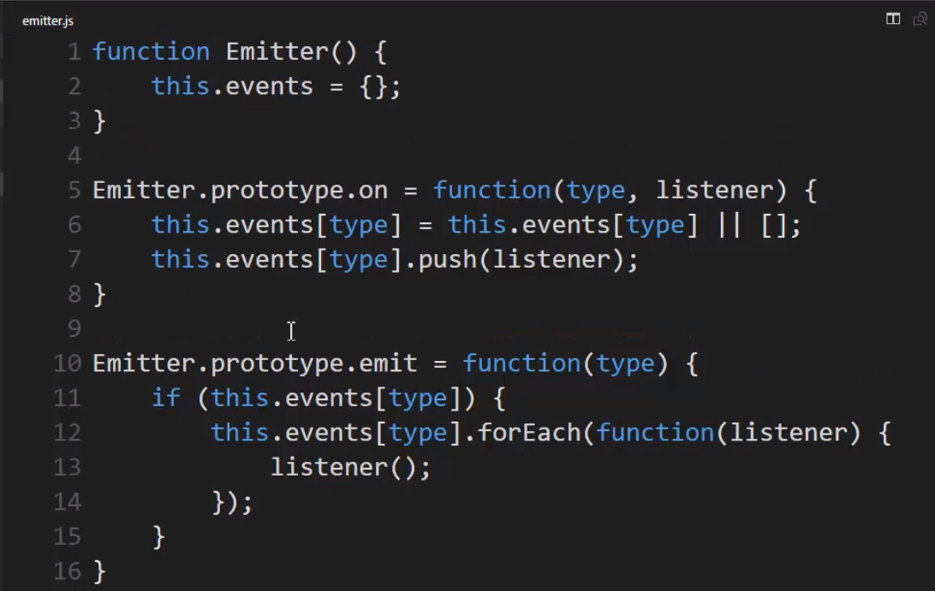 

Another way for For each - 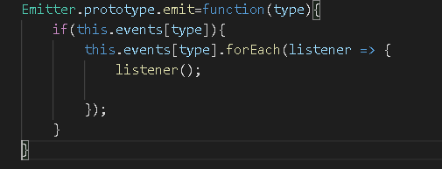

My method I'm adding here is on, and that's essentially to add a listener. Again, these aren't real events, this is just a trick.

**Note** – this.events[type]=this.events[type] || [];

**Meaning - if the property already exists then great, otherwise, make a new array.**

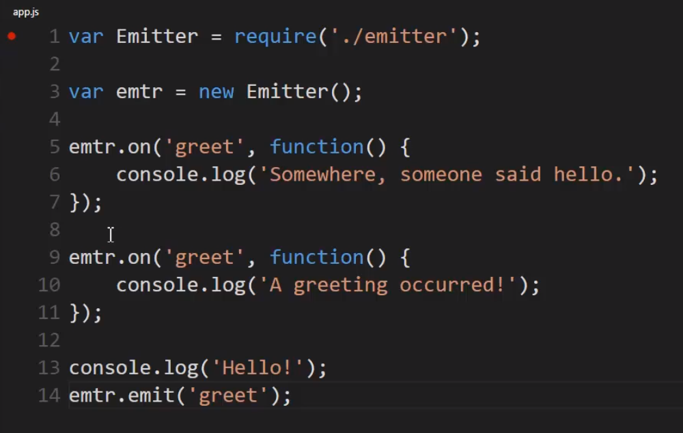

 let's pretend that I have some sort of event called greet, where when a greeting happens, I want to respond to it.

So I'll take my emitter and say on, and pass the string, that say greet. Then I'll pass the function the listener, and I'll just do it on the fly here, I'll say somewhere, someone said hello.

**This will run whenever the greet event is emitted**

**I manually emitted the event. And what emit does is just finds this property and loops through the array, and runs all the functions in the array**

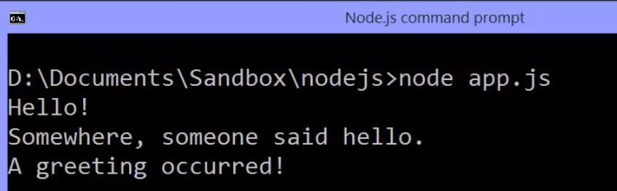

When you debug it - 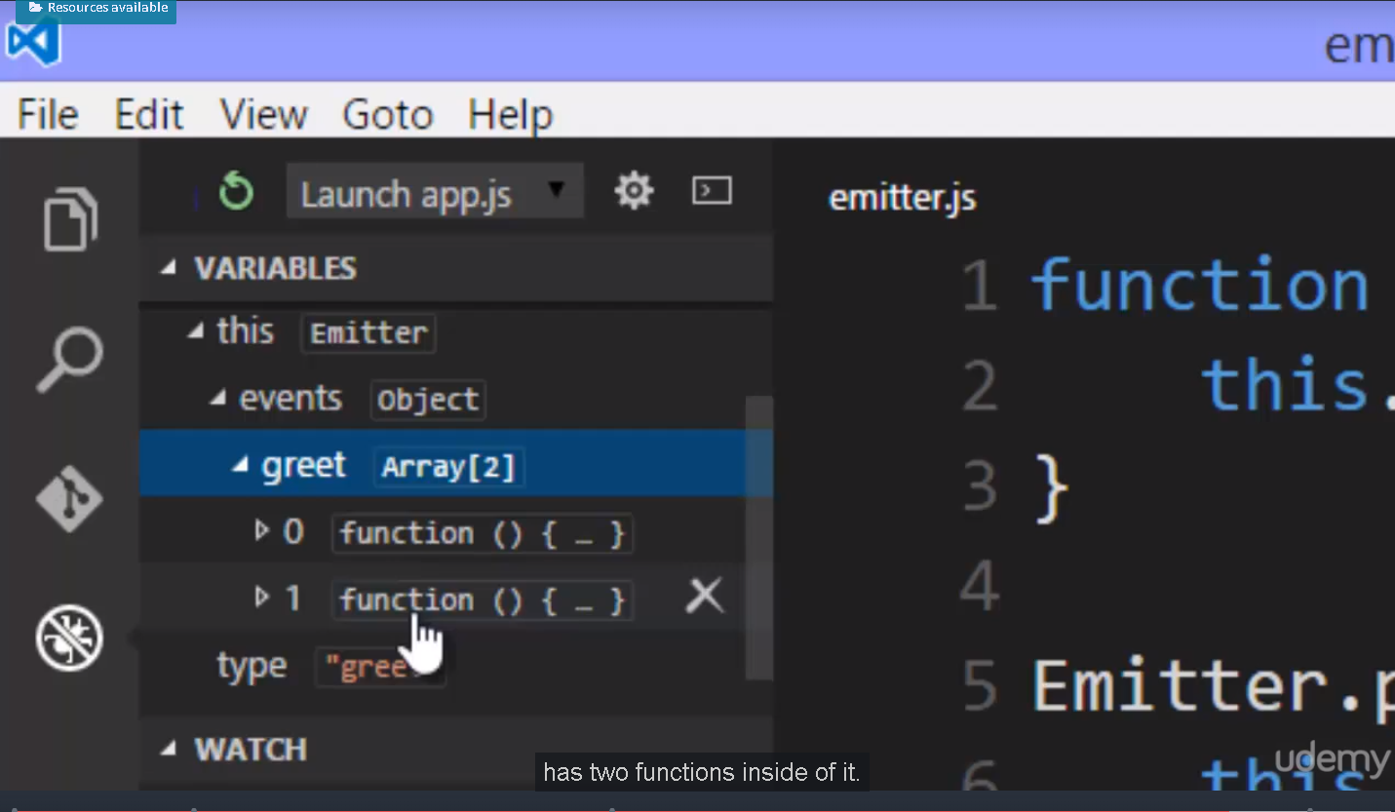

## 34.Node Event Emitter – Part2

**Let's look at the Node Event Emitter.**

**Lets look at the nodeJS official api documentation.**

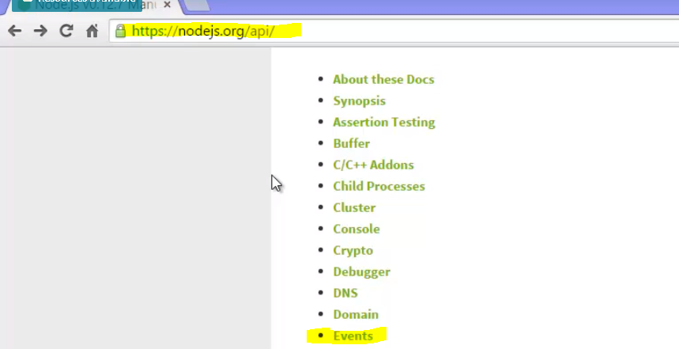

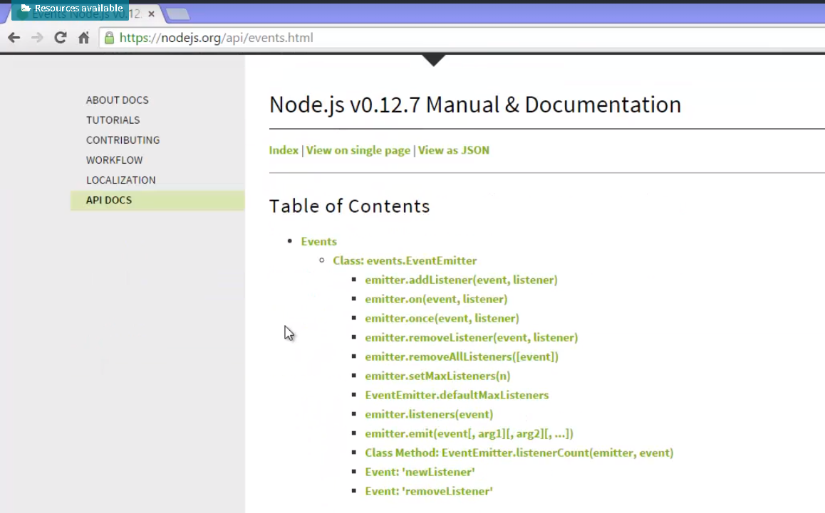

**Lets take a quick look at the actual code. Under the lib folder in the actual Node.js source code, there's a js file called events. And so, if I scroll down, we see that there's a function constructor called event emitter. And that is what is put on module.exports.**

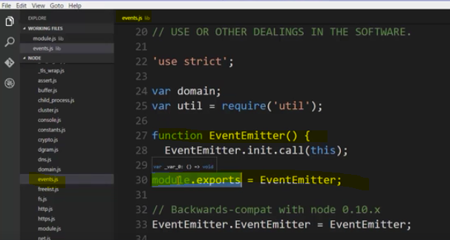

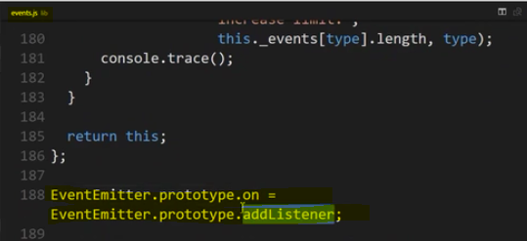

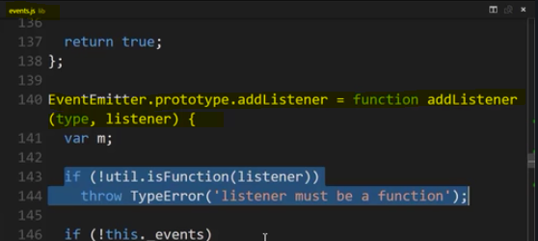

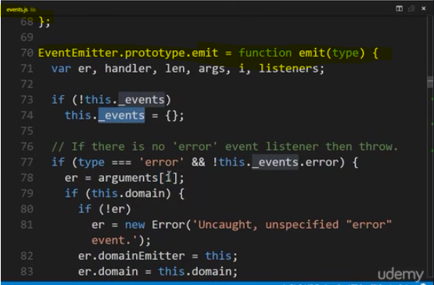

when it comes to the JavaScript side of Node. And we'll skip a lot of this, because the event emitter for Node has a lot of extra features than what we build as our own event emitter, and of course it does.

We built the simplest possible version, but this is a much better version, and the one you should use.

notice here we have an **emit method**, which takes a type, which is really just a property on this hidden events object. If I dig down in here for awhile, I can actually see that when I'm emitting events, that is I'm saying that something happened, if I scroll down a ways, it actually uses **.call,** which is, if you're not familiar with that, another way to invoke a function. So in other words, it's saying, ah, I have a handler for this event, or maybe multiple handlers, and so if I just have one I'll call it, otherwise, it loops across all of them and calls all of those different listeners. So it just used a for loop to loop across the array, and then for every listener in the array, it calls **.apply**, which is another way of invoking a function. So it's just running functions that are sitting in an array on a property.

And if I look for **on method** inside all this code, I'll see that it's actually just shorthand for add listener. So I find my **add listener function** inside the Node Event Emitter, and this takes a type and a listener, the listener being a function. In fact it even double checks that it is.

That's why the Node Event Emitter is better than the one we built. It has a lot of features,

and is a lot safer to use, but it's still the same basic concept. A type, which is really going to end up being the property name on the object. And then the listener, which will be a function sitting in the array.

And so it checks that object that it has inside it is there. And then it actually has a little bit different logic for the way it adds events in here. If you only have one listener, it doesn't bother making it an array. As soon as you add a second listener, it converts the value to the array, and then after that it just pushes more listeners. But it doesn't really matter how this works internally here because we use it the same way.

And it even has some extra code to make sure we don't have any memory leakage, and some other things. But, it still works the same way. We have on and we have emit, and some other methods that you can see if you look in the documentation.

**Lets use nodeJS native events module -** 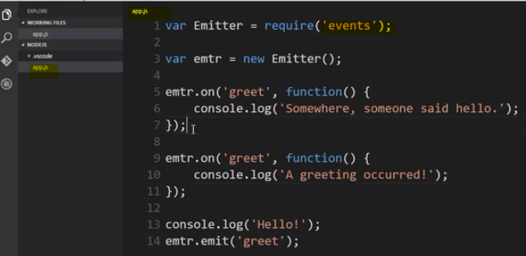

I just used the internal Node Event Emitter. Pretty neat, right?

Again, a really clean way to structure responding to things that happen in my app. I say manually that they happened, and then all the functions that I've ever set up for when that happens, run.

Now, you may be thinking, well what about across modules and in different files? Well you can do that, but you'd have to structure your modules properly, perhaps passing the emitter around, or calling the functions and passing it as a parameter if you want to use the same emitter across different modules. But that's actually somewhat unusual. Usually, we're worried about the object that we're currently working with. That it's emitting events and I'm listening for them. And so that's usually happening within a single module. Just like we're doing here.

But there might be plenty of code in this module that we're listening for that particular event, and then running it in different places in the module itself.

**There's one problem with this trick when it comes to the event emitter. It relies on what's called magic strings.**

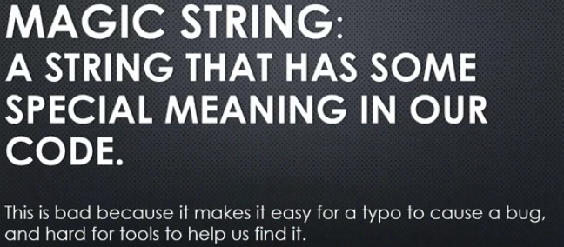

We mean a string that has some special meaning in our code. You have an if statement that says if the string equals this, then do this. And that's essentially what our event emitter is because we give it a string, and that determines the property on the object we're looking for.

**This is bad because it makes it easy for a typo to cause a bug. I type the wrong string, and suddenly it doesn't work. And worse because it's hard for tools like Visual Studio Code or others to help us find that bug because it's just a string. It's not a variable. So, any tool that we might be using can't just tell us oh, I don't recognise that variable.**

So, relying on strings to be the basis for the logic in your code can be problematic, and a string that is one of those things, something that we are relying on, it's called a magic string.

So there is a few ways to deal with that.

Let's quickly show you one way to deal with strings in this example, for events.

Let's fix the fact that we're relying on this string for our event emitter to function properly. We still will need the string, but let's remove the fact that we're relying on typing it correctly, without any kind of help from the debugger, or from a tool. Now you don't have to do this.

This is just a pattern, but when you are especially working in larger apps, many developers, it's a really nice pattern.

**Lets create a config module, and each event that I can have in my application will get a property on this object.**

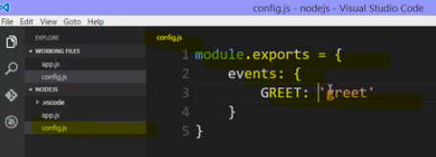

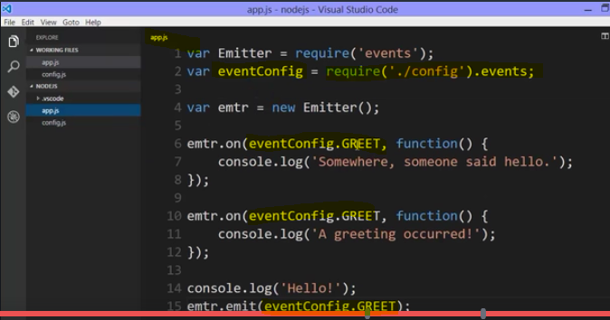

**then everywhere I had greet, I can use that property name in place of the string because that's its value. Remember this is just a string value, so that string is what will be passed here. And also notice, that because I'm now using variables and properties, tools like Visual Studio Code are able to help me grab those property names. So this works out a lot better for me, because it helps me avoid accidentally mistyping the property, and if I did type it incorrectly, the error I would get would be more helpful. That this property doesn't exist on that object, or that it's undefined. it still works the same way, and I'm still just passing strings, but I've gone and centralised the strings themselves, and then used those properties everywhere.**

**And that also means I could just change the actual internal name of the event, the string itself if I wanted, in one place, and it would change everywhere in my app. But this makes it harder to make a mistake.**

So that's why it's a nice pattern.

There are many modules in Node. Built in core JavaScript modules that are built on top of the event emitter, so understanding the event emitter not only lets us use it in our apps, but also understand many other modules where you'll see a dot on, and a dot emit.

## 35.Javascript Aside : Object.create and Prototype

**Concept explained in understanding weird part javascript course. Please refer**

## 36. Inheriting from the event emitter

**Let's look at inheriting from the event emitter.**

There are a number of ways to set up the prototype chain in JavaScript, that is inheritance in JavaScript. We've seen function constructors where the .prototype property of the function is what all objects created from that function constructor point to as their prototype. There are ES6 classes and a keyword called extends, and we've seen object.create.

**Within util.js, the util.js file, that module inside the Node.js source code, there's something to help us with inheritance. It's a method called inherit, and it takes two constructors. A function constructor, upon which you want to add new methods and properties to be available to objects created with it, and another constructor, where, that's where the properties and methods you want to be added onto your objects, made available to your objects are sitting,**

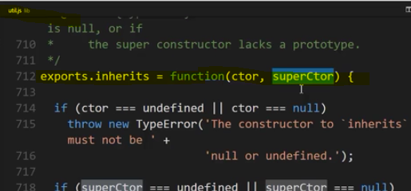

and essentially what it does is use these same concepts we've already seen within JavaScript to help us more easily make the methods and properties on the prototype property of this constructor available along the prototype chain for objects created with this constructor. First, it does a bit of error handling, and checks to make sure that each of those functions are function constructors and have a proper prototype set up and then, here's where it gets interesting.

The constructor that we want to add onto, we look at its prototype property. Now, notice this is being set equal, so if you call inherit after you've set up some methods and properties on this .prototype property, you'll actually override them. So, you need to do this first before you add any other methods and properties to your prototype.

Now, the constructor then, has its prototype property and that's set equal to Object.create, meaning creating a new empty object, with the super constructors or the constructor we're looking to get some properties and methods from, off its prototype property. So, an empty object who's prototype is this prototype property of that function constructor, and that empty object, which just created a chain down to this prototype object will be the prototype property of that function constructor, which means any objects created from this function constructor will end up at the top of this prototype chain that involves both this property and this property.

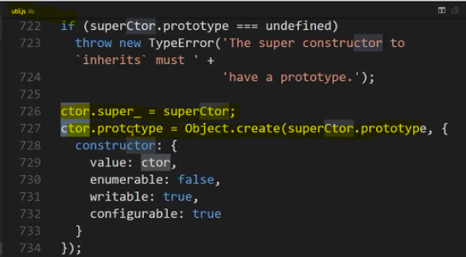

Alright, it looks a little confusing, but let's look at it visually.

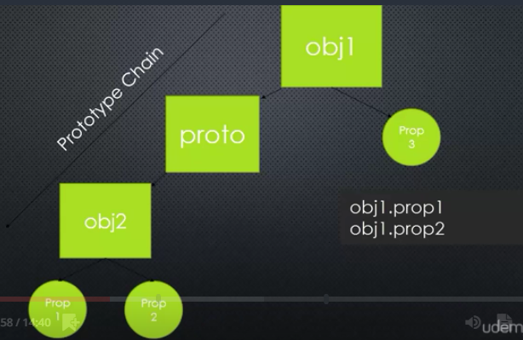

What nodes inherits function does using function constructors and Object.create, is it simply places a prototype object in between the two. It creates a brand new prototype chain. So, it takes the object that we have, and says, "Well, your prototype", that object that I already have and I need to have more features added to it, it says, "Well, your prototype will have its prototype "be the thing that you're actually looking to add on", and because of the way the prototype chain works, I will then have access to those properties and methods a little ways further down the chain.

So, Object One, will now have access to the properties and methods on Object Two by means of using Object.create, which created the empty middle prototype object,

Alright, let's see this practically by inheriting from the event emitter.

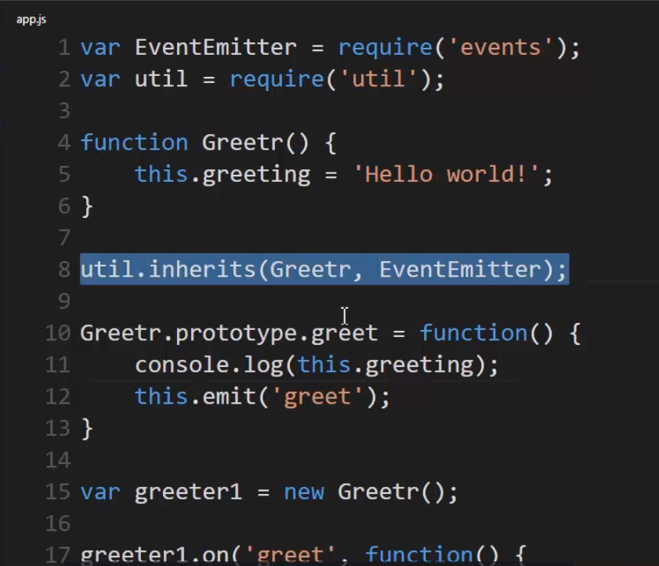

I'll say that any objects created from Greetr should also have access to the methods and properties on the prototype property of EventEmitter. So, essentially, any new objects I create from Greetr, will also get all the EventEmitter methods and properties, and I can still add my own extra methods and properties

lets run above code - 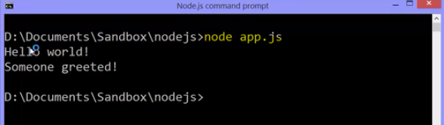

Now, I emit the event and if I want to pass this data to all my listeners, to all the functions in that array that will be invoked,

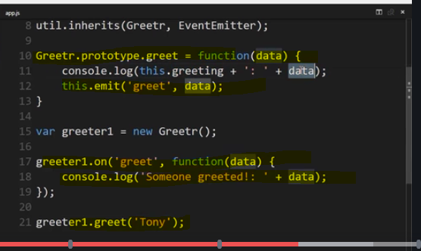

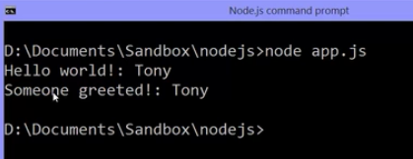

Lets understand what happens behind the scene visually

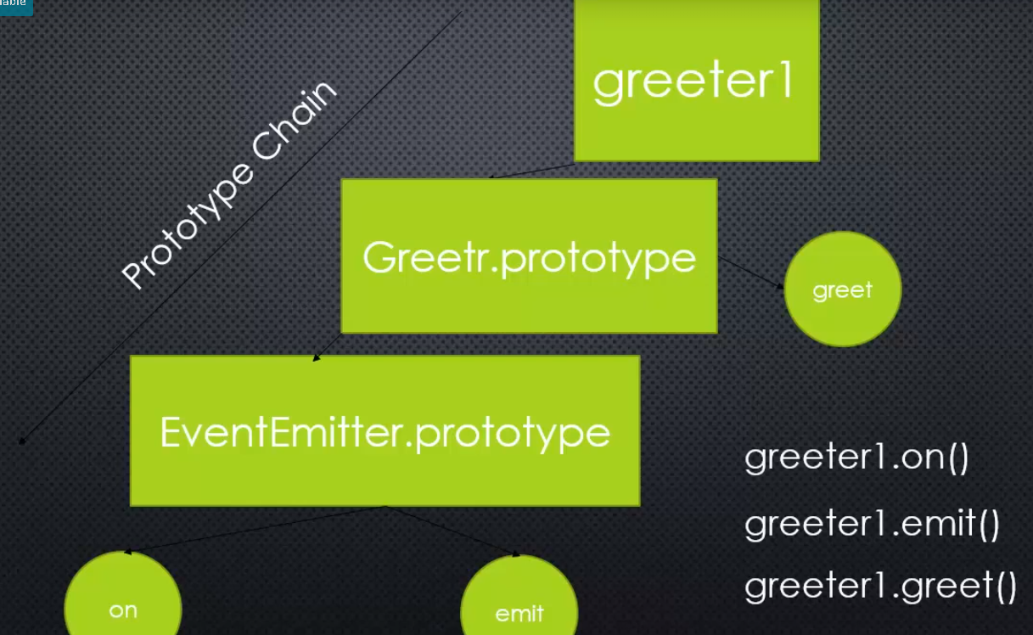

**Well, we had this object. It's sitting on the prototype property of the EventEmitter function constructor. So, any objects created from that EventEmitter function constructor will point at this object as their prototype, and it has some methods on it, some features that we want, like on and emit.**

**but we don't wanna just create an EventEmitter, we wanna create another object that does more than what the EventEmitter does, but also does what the EventEmitter does.**

**So, we used util.inherit**

which essentially said, "I'll take this other "type of object, that does other things that you want, "and its .prototype property "will have as its prototype, the EventEmitter's "prototype property", so it set up a small prototype chain, and then, when we said, "new greeter", that's what we get, greeter1 points to that Greetr.prototype object and Greetr.prototype points to the EventEmitter.prototype object, and the greeter itself had a greet method, and so, that's our prototype chain.

My new object down its chain finds the Greetr.prototype object, and down that chain, it finds the EventEmitter.prototype object, which means I can call .on, .emit, and .greet, on my object at the top of the chain.

This concept then, of essentially, to be able to create new objects that have a combination of the functionality of one object and another object,

you'll find all over inside the Node.js JavaScript Core, and very often, the objects are inheriting from the EventEmitter.

There are many event emitters inside Node.js that you can listen for events, you can emit events, but they're actually more than just an EventEmitter by themselves.

**Alright, just understanding this concept then, that we might have an object, a type of object in Node that both does many things and emits and allows you to listen for events, is a key concept with Node,**

**and as we move on, we're going to see other objects, key objects, in building software applications in Node that allow you to listen for and emit events because they have the EventEmitter down their prototype chain.**

**That is to say, many objects built into Node are a type of EventEmitter. They emit events and you can listen for them, run code, when a particular event happens.**

## 37. Node, ES6 and Template Strings

Something really exciting is happening in the world of Node and Javascript in general.

Let's talk about Node and ES6, and see an example with Template Strings.

To begin with, the new version of Javascript is called ECMAScript 2015, and is often referred to as ES6. It's the new standard for Javascript and it includes new features to make managing writing Javascript code easier and to add some of the things that Javascript was missing.

**the latest version of Node includes the latest version of V8 embedded inside of it. And the latest versions of V8 have more support for ES6.**

Now the idea here then is that you can start writing in this latest version of Javascript if you want. Now you don't have to, but it does include features that can make your life easier. Now that said, that doesn't mean that you can start right away in the browser because not everyone will be using the latest version of the web browser that they're using which means that their Javascript engine inside their browser may not support it. You may not also have the luxury of having the latest version of Node on the server that you're actually pushing your code to. So this needs to be a decision that you make carefully with you and perhaps the dev team that you're working with in building your software.

Now that said, it can be nice to write ES6 everywhere, because if you're writing new features in Javascript and Node, you can get yourself confused and start using those new features in the browser when writing web applications and by accident between switching back and forth forget that something isn't available on the web when it's available in Node. And so it's nice to just be able to do it entirely in ES6.

If you're interested in writing ES6 in the browser and have it work everywhere, you can take a look at **babeljs.io**. And what that does it takes the new features in Javascript, lets you write them, then it converts the code you write into older Javascript into something that will run on all browsers. So it's not that you're really writing ES6, but it lets you write the same syntax and convert to an older version of Javascript when it's actually run in the browser.

**with Node is the actual V8 engine supporting these features. So it's not fake, it's real. We're talking about ECMAScript 6 running in V8, new features in Javascript.**

So as we go through this course, we'll talk a bit about some of these features and how you can use them, but it isn't required to use them in your code.

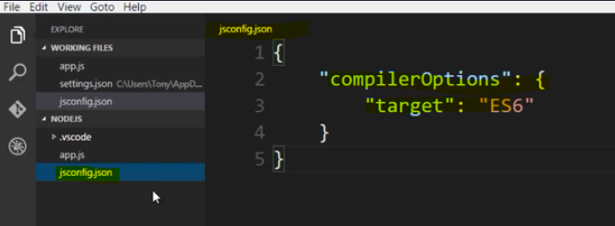

if you're using VS code and only if you're using VS code, since we'll be writing on occasion ES6, the latest version of Javascript code, you might need when we're writing ES6

a Javascript config.json file in the folder that you're writing your code in. This file is simply telling VS code that this folder contains ES6 code, and that certainly won't stop it from working if you don't have this because we're actually running the Javascript in Node. But, it does let VS code not warn us or give us warnings about features that don't exist in previous versions of Javascript. So I can write some of these new features and VS code won't complain about them

Template Literal is a way to concatenate strings in Javascript, that is the new version ES6. And it's easier to work with than a bunch of strings concatenated with plus operator

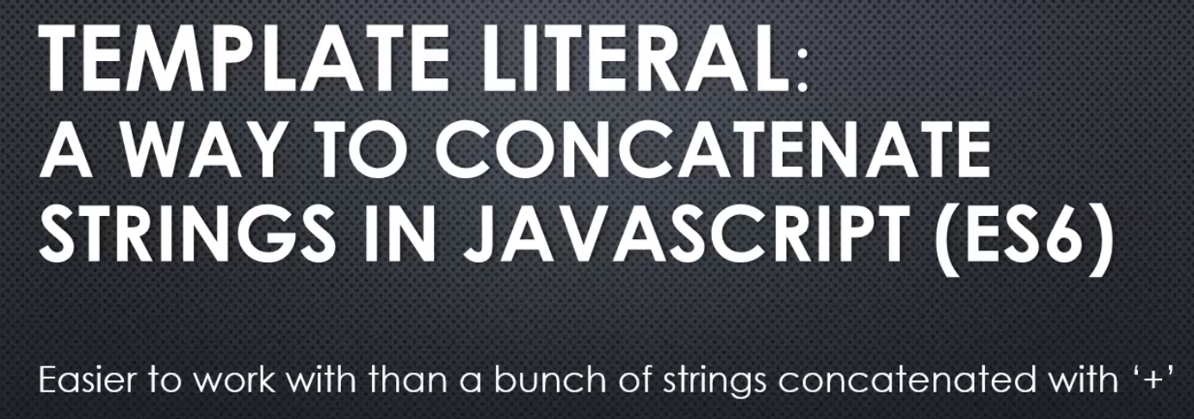

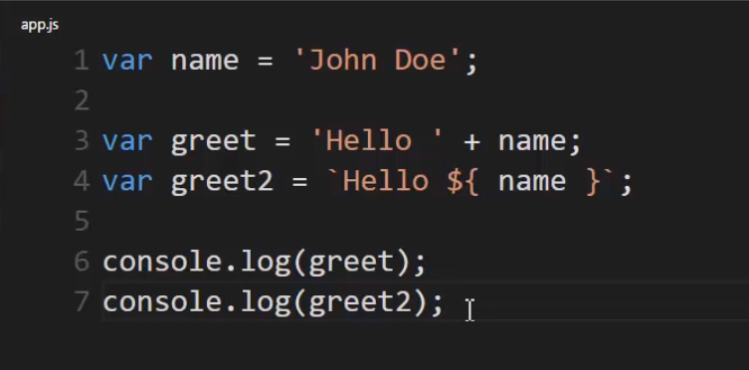

**Instead of using a single quote, I'll use what's called a back tick**, or a grave accent, that's found usually in the upper left corner of your keyboard if you're using the US or UK qwerty keyboard layout.

So, the back tick, it's not a regular quote, but rather a back tick or grave-accent mark, and **that tells the Javascript engine that this is going to be a Template Literal**. I can put a regular string it, but wherever I want something that's evaluated, a variable, an expression, whatever the case, I put dollar sign and then curly braces. Curly braces like I was doing a block like an if, or a for, or an object literal. And inside those curly braces I can put Javascript code and then terminate the Template Literal with a back tick or a grave accent.

So this is a Template Literal. It let me insert Javascript code without having to stop the string and use pluses to concatenate and everything else. This is a lot faster and easier and less prone to mistakes.

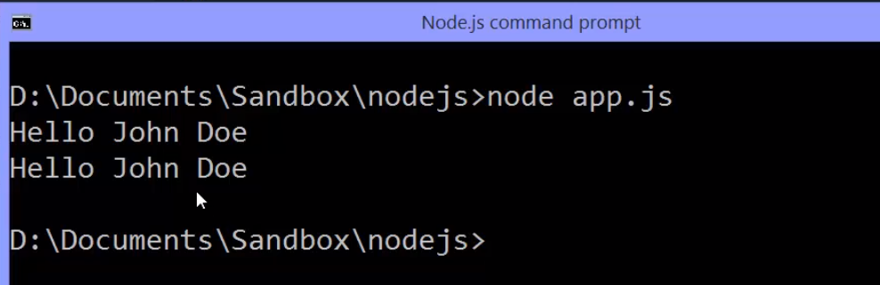

Now again, i can't do this in every browser, because it may not be supported. If I want to do this in the browser I have to use something like Babel in order to conver this to this.

**So Babel would take this code I've written and convert it to this before we actually give it to the browser. But in the case of Node I can just use this as is, give it straight to the V8 engine because it's the latest version of V8 engine, this is supported.**

## **38 Javasccript Aside : .bind() .call() and .apply() for invoking function**

**Concept explained in Understanding Weird parts of javascript course**

**Please refer**

## **39. Inheriting from Event Emitter- Part2**

there's one scenario that we haven't covered.

**Inside the function constructor, we can add properties and methods directly onto**

**the object being created, as opposed to properties and methods on the prototype.**

**The this keyword is the new object being created whenever I say new and then function constructor. So that's how I add properties and methods.**

But what if EventEmitter, or whatever else I'm inheriting from also adds properties and methods directly to the new object, not necessarily the prototype?

It's an incomplete form of inheritance. So we can fix that up very easily with one line of code.

Inside my function constructor, I'll say EventEmitter.call(this).

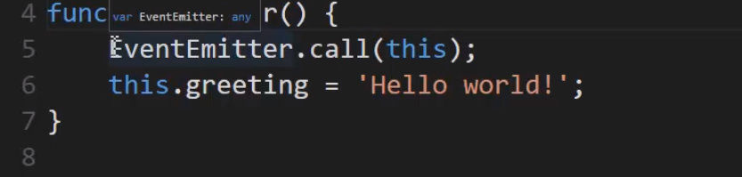

Now what does that do?

**Well EventEmitter is a function constructor. And so when it's invoked with the new keyword, the this variable points to an empty object and it adds on properties and methods.**

**But I'm overwriting what the this keyword is. So I don't need to use the new keyword. All I need to do is say run the function constructor And pass the new object that has already been created, then inside the EventEmitter function constructor, I'll have a bunch of properties and methods added if there are any to it.**

**And because this is passed by reference because it's an object, then I can just keep adding on my own properties and methods to that new object.**

This is equivalent to what some would call in other programming languages, the super constructor. Meaning the constructor that I'm inheriting from.

But the **basic idea is simply this in JavaScript. I'm using .call, I could also use .apply in order to give it the new object that I'm working on so that it does it's work of adding properties and methods to that new object. So the this keyword inside the EventEmitter will be the same this inside Greetr, add all of the properties and methods, add my properties and methods, and then the prototype chain is still set up the same way.**

So this one line of code ensures that my object created from this function constructor has everything an object created from an EventEmitter would have.

Lets look at some simple example –

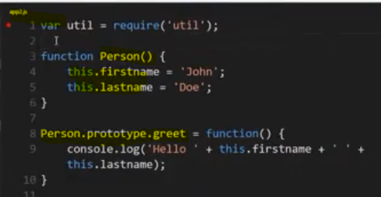

I want to make another function constructor. I called it Policeman. And this object has its own special property called badgenumber.

But I also want Policeman to have everything that Person has access to.

So I used util.inherits and said Policeman should inherit from Person. And now I make a new Policeman and call the greet function.

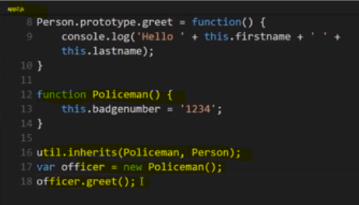

What do you think's going to happen?

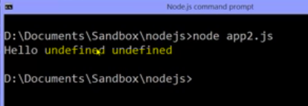

Why?

**Because util.inherits just connected the prototypes. It connected what's available to all objects being created from this function constructor.**

**But the actually constructor person was never run that actually attach properties and methods directly to the new object being created**

**So if I add Person.call(this) what happens is when I create a new Policeman, this function is called (person()) and because of the new operator, the this keyword points to an empty object. And then I run Person and give that empty object to Person and since I'm using .call,**

**the this keyword will be the same object as the this keyword here. Hence it will attach property to Policeman function constructor object**

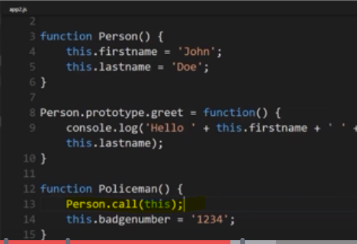

**Withot the .call I didn't have the first name and last name, because that function constructor was never actually run. Util.inherits just connected the prototypes.**

**With .call, I make sure that the object has everything, not just what's down the prototype chain, but what's supposed to be directly on each new object.**

Lets see in debugger

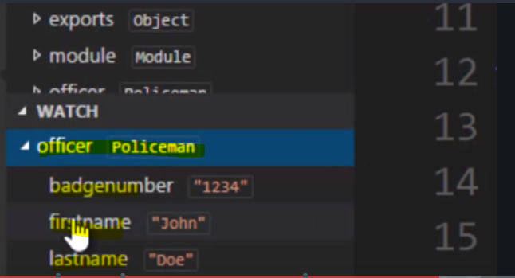

I needed to go one level deeper down the prototype chain, another .proto.

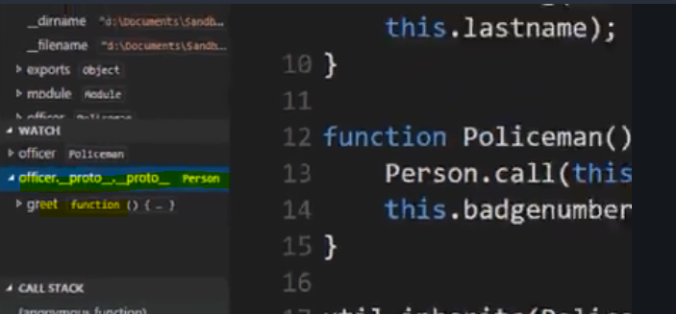

Output –

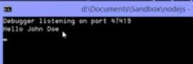

## ES6 Classes

**Concept explained in Understanding Weird parts of javascript course**

**Please refer**

## Inheriting from event emitter- part 3

Let's try updating where we inherited from the event emitter to use ES6 classes.

Previously we  inherits from EventEmitter using util.inherits provided by Node, and simply sets up the prototype chain.

Now let's update this using ES6 classes.

I'll just add use strict to make sure I tell the V8 engine that I'm using the stricter version of JavaScript, that is to say more errors, it won't let me do as many things, and that will make classes available to me in this version that I'm using now.

how can I make sure that the EventEmitter's constructor is also called?

Well, with classes, instead of directly calling the parent of the class, the parent of the constructor, you just say **super(),** and that actually does the same thing.

**But in order to call super, you have to say what you're inheriting from.**

Now down here we used util.inherits But with class, that's been simplified. Even though it still does the same thing,

all we have to type is the keyword extends and then EventEmitter. **So that means that Greetr will extend EventEmitter.**

Now you may be wondering, hey, this is Node, can I use this in a module?

**Absolutely, because class is just syntactic sugar. It works essentially just like a function constructor, and I can use it in a very similar way.**

I'll actually now export the class using what's called a class expression.

See that, I'm using a class just like any other variable and just like I can a first class function. So I'm exporting the class itself and that's it.

